Assignment 03: ASP.NET Controls

In this “hands-on” activity, you will discover more details about creating ASP.NET pages that use various controls. This activity will take you about 3 to 6 hours, so plan accordingly!

The activity consists of the following steps:
- Study web resources.
- Create your demo.
- Document your demo.
- Submit your work to the Canvas site.

Study web resource:
Please familiarize yourself with the following topics. Try to figure out what they all, generally, have in common. You do not have to read these pages in detail, I just what you to know what is out there for information.

1) What are Web Forms
https://www.asp.net/web-forms/what-is-web-forms

2) Walkthrough: Creating Reusable Elements with ASP.NET User Controls
http://msdn.microsoft.com/en-us/library/3457w616(v=vs.100).aspx

3) Walkthrough: Creating and Using ASP.NET Master Pages in Visual Web Developer
http://msdn.microsoft.com/en-us/library/ehszf8ax(v=vs.100).aspx

4) HTML Helpers used in Modern ASP.NET
https://www.codeproject.com/Articles/787320/An-Absolute-Beginners-Tutorial-on-HTML-Helpers-and

Create your demo
In Module 3, you saw many web page examples. These pages included various ASP.NET web controls, Master and Content pages, and MVC controller/views.

Now that you have seen how others describe and demonstrate these concepts, try out your skills by creating a new ASP.NET project using a Web Form with a Master and Content page option (Figure 1). (We will work with MCV later in the course.)

1) Create a new ASP.NET website project called “Assignment03.”
2) Create a new Master Page with navigation buttons on the top of the page.
3) Create a new Home.aspx Content page.
4) Create a new LoginRequest.aspx Content page.
5) Create a new AboutUs.aspx Content page.

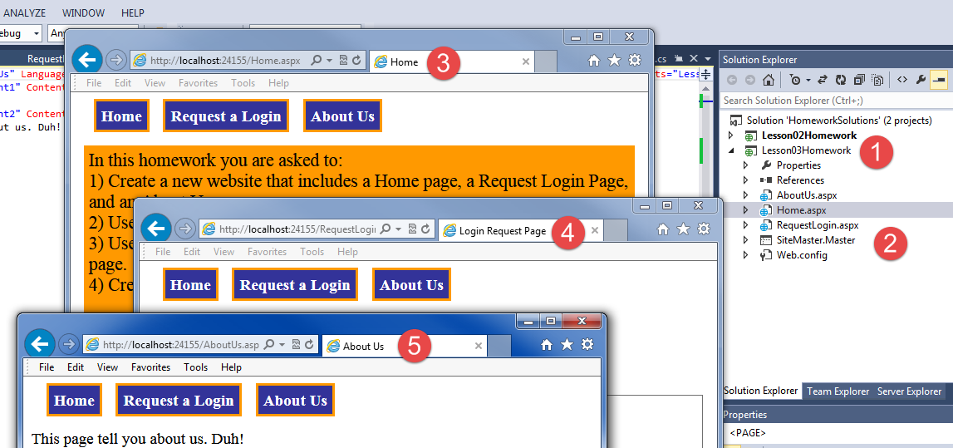
Figure 1. The three pages needed for the assignment

Write a Paper
Create a Word document that outlines how to create and test an ASP.NET website using the Master/Content technology.
Write the document as a simple tutorial that coworker could read to understand what this technology does and how you might use it.

The document should be about 2 to 4 pages (including any pictures) in length, including screenshots. Please use Microsoft Word or something compatible with Word. I recommend that you start with the images, place them in your Word document, and then add a short paragraph to describe what you are seeing/doing.

NOTES:
1) Read this two-page article on creating technical documentation before you start: http://www.developer.com/tech/article.php/3848981/The-7-Rules-for-Writing-World-Class-Technical-Documentation.htm

2) See this page, if you need help getting screenshots: ( http://m.wikihow.com/Take-a-Screenshot-in-Microsoft-Windows).
3) Format it like a college paper instead of the text message. I always expect things like having your name, date, class, and citations on your documents!

Submit your work to the Canvas site
After you complete you your Assignment website, place the resulting files and folders into another folder, both the document and the Visual Studio Solution/Project sub-folder, and turn everything into a single zip file. Then post the zip file on the Canvas website, in the appropriate module under Assignments.
(http://www.wikihow.com/Zip-Files-Together)

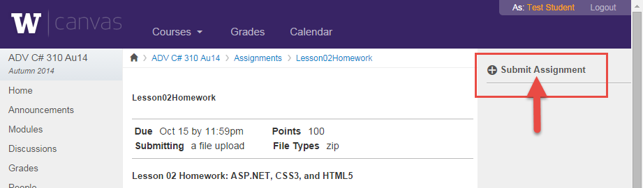

You’re done!

